STEP 1

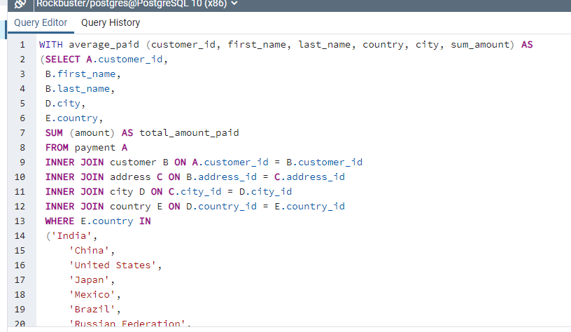

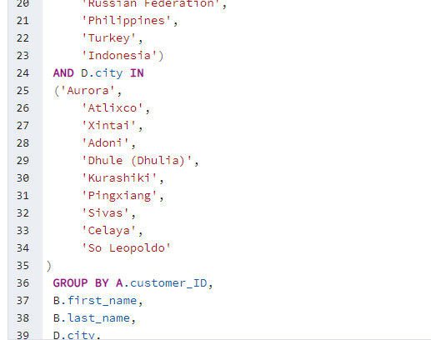

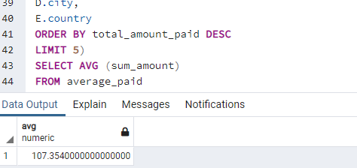

STEP 2

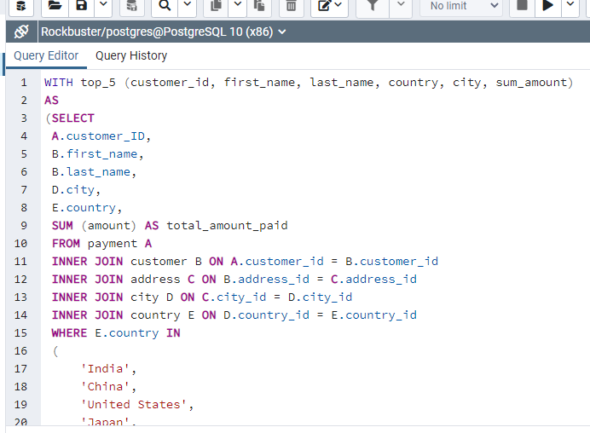

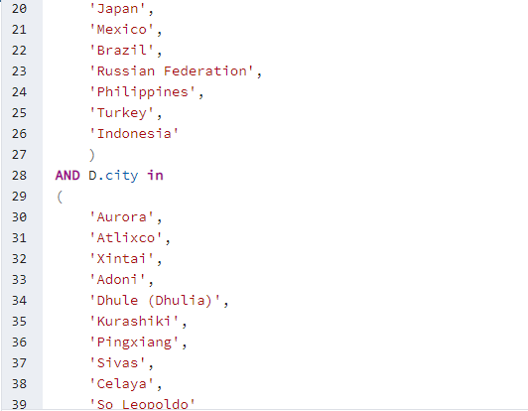

Question 3

* First, with CTE I had to put it under a name WITH average _paid.
* I, then used the queries from exercise 3.8 (previous exercise) and then used the SELECT

I expected the CTE to bring about a change but the difference was not significant.

